Jeet Kumar October 23, 2024
Lab 21 DVWA
- Command Execution
  - By looking at the source code we know that the php file only executes the request without doing any confirmation on $target. This means we can use “;” to add a command within the request to gain more information about the target system. If we add cat/etc/passwd to the end of the request we can get information related to the accounts on the system.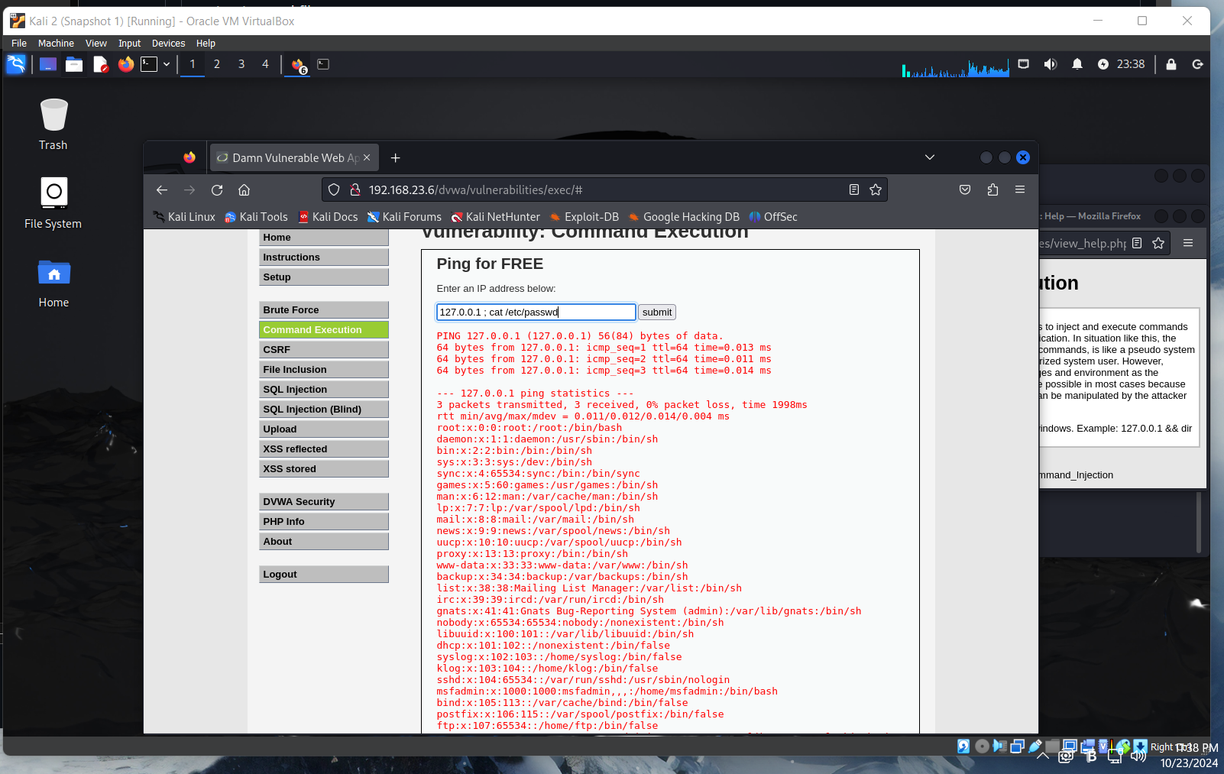
- CSRF
  - Using Burp, we can get the address of the page the user is attempting to access. In the web address, we can see that the password new and password confirmation are shown in plaintext which is a clear vulnerability that we have exploited.
  - 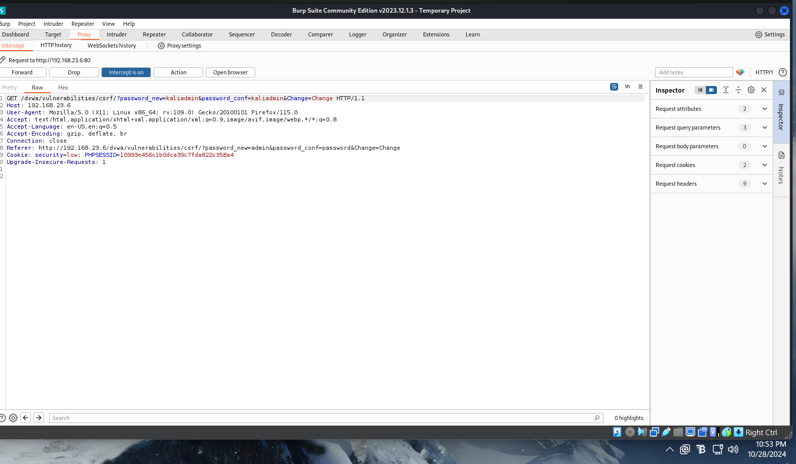
- SQL Injection
  - By looking at the code, we can see that there is no input validation for true statements so if we input a statement that is always true then we should get information.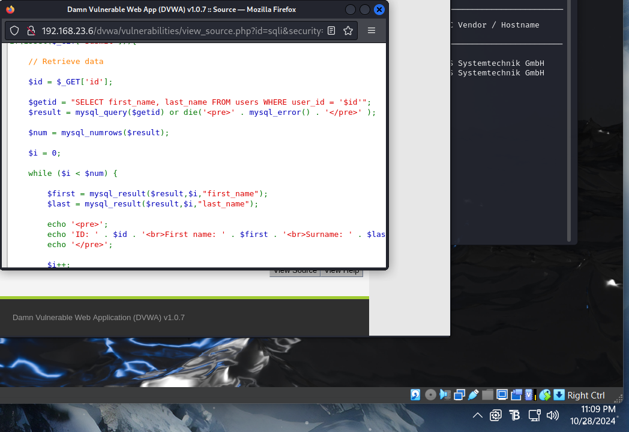

  - 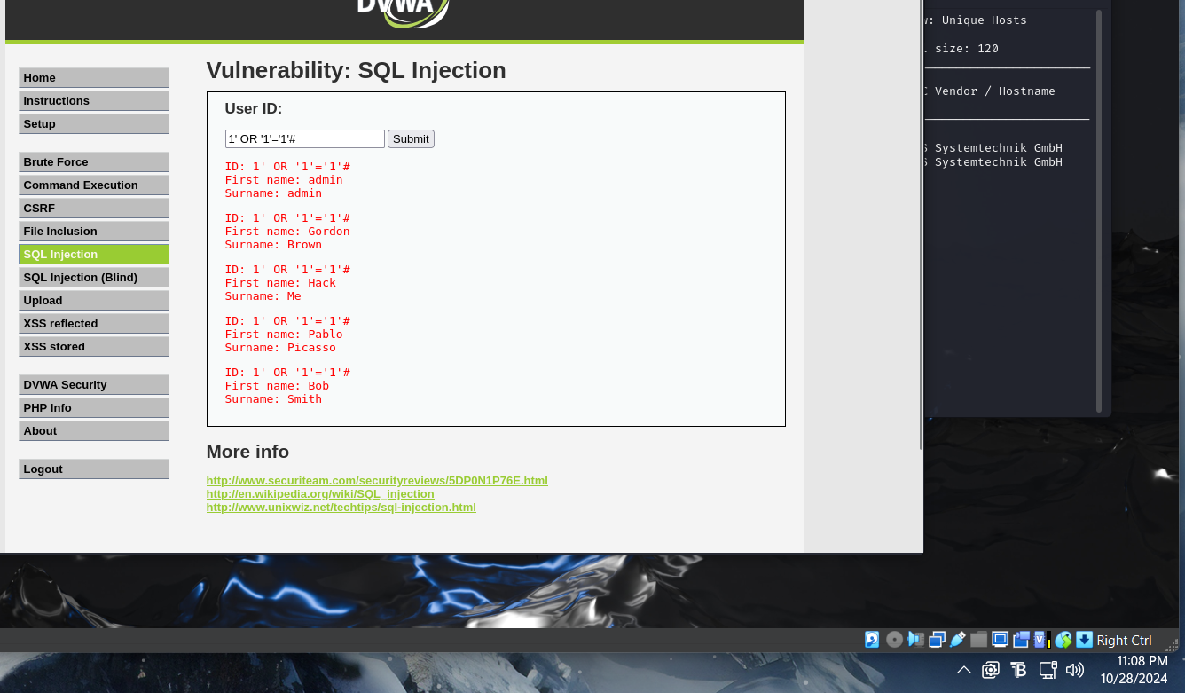
- XSS
  - From the code, we know that the input is gathered by the field and then it is reflected back to the user using the GET clause. 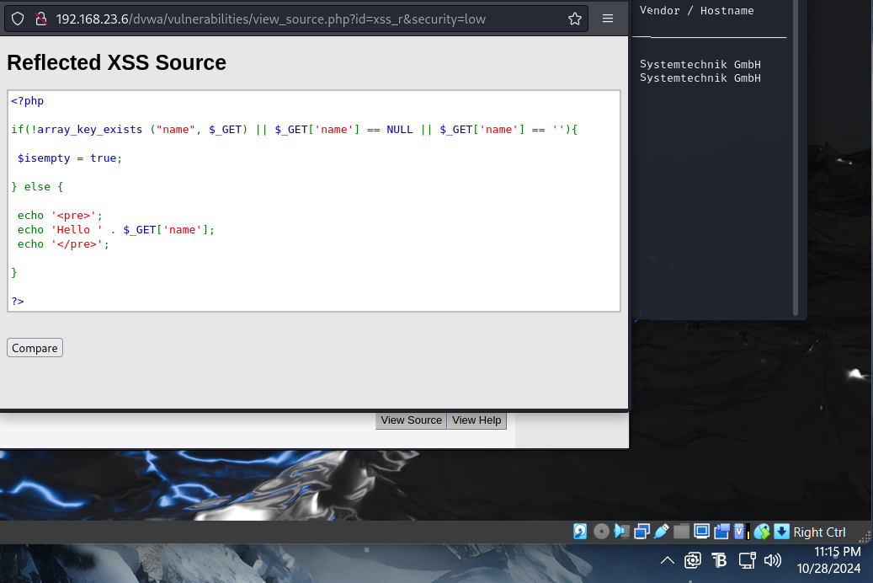
  - Using information listed here https://cheatsheetseries.owasp.org/cheatsheets/XSS_Filter_Evasion_Cheat_Sheet.html, we can input some code to create an alert that will output some important information. If we input “<script>alert(document.cookie)</script>”, we can create a request for a session ID which I believe can be used to create a session hijacking attack. 